AI Prolog Assignment - III

Outputs :-

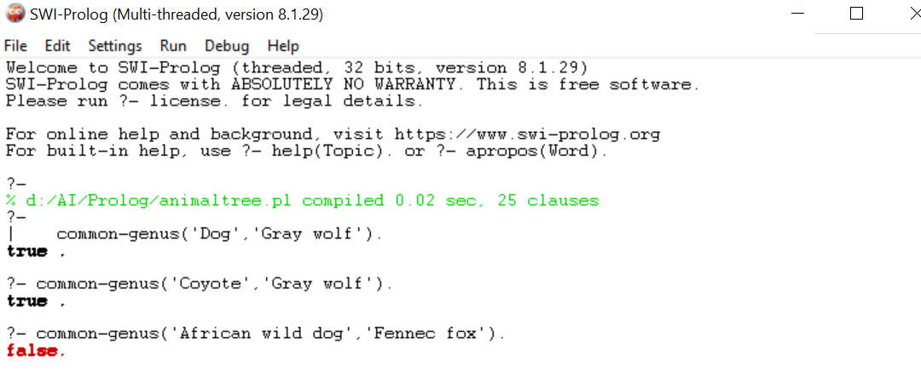

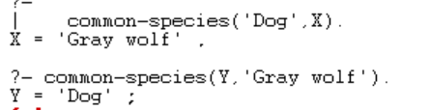

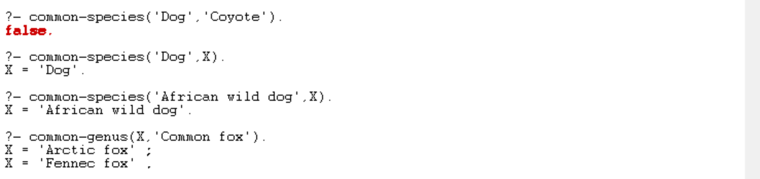



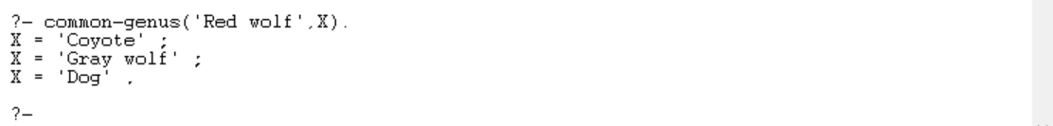

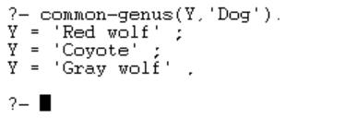

It shows false here because in the genus of Lycaon, no other species is there.

